SESSION 4
NAME: K NAVYA
REG: 192371022
COURSE: CSA0603 DAA
1. In a string S of lowercase letters, these letters form consecutive groups of the same
character. For example, a string like s = &quot;abbxxxxzyy&quot; has the groups &quot;a&quot;, &quot;bb&quot;,
&quot;xxxx&quot;, &quot;z&quot;, and &quot;yy&quot;. A group is identified by an interval [start, end], where start
and end denote the start and end indices (inclusive) of the group. In the above
example, &quot;xxxx&quot; has the interval [3,6]. A group is considered large if it has 3 or
more characters. Return the intervals of every large group sorted in increasing
order by start index.
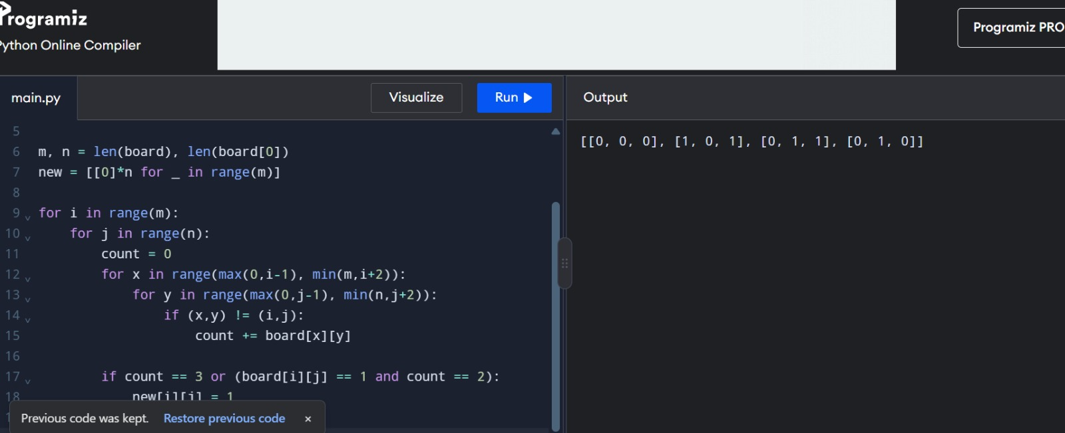
2. The Game of Life, also known simply as Life, is a cellular automaton devised by
the British mathematician John Horton Conway in 1970.&quot; The board is made up
of an m x n grid of cells, where each cell has an initial state: live (represented by a
1) or dead (represented by a 0). Each cell interacts with its eight neighbors
(horizontal, vertical, diagonal) using the following four rules
Any live cell with fewer than two live neighbors dies as if caused by under-population.
Any live cell with two or three live neighbors lives on to the next
generation.
Any live cell with more than three live neighbors dies, as if by over-
population.
Any dead cell with exactly three live neighbors becomes a live cell, as if by
reproduction.
The next state is created by applying the above rules simultaneously to every
cell in the current state, where births and deaths occur simultaneously. Given
the current state of the m x n grid board, return the next state.
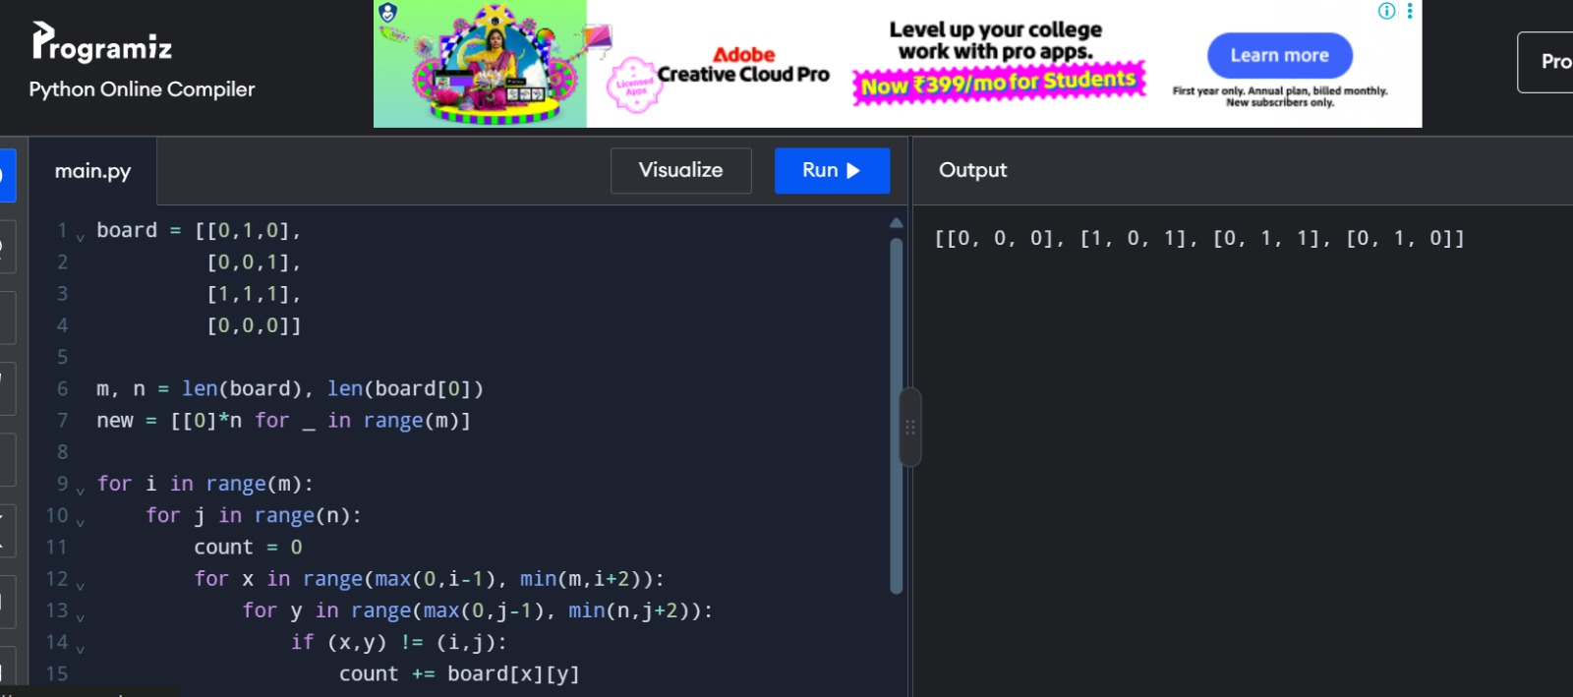
3. We stack glasses in a pyramid, where the first row has 1 glass, the second row has
2 glasses, and so on until the 100 th row. Each glass holds one cup of champagne.
Then, some champagne is poured into the first glass at the top. When the
topmost glass is full, any excess liquid poured will fall equally to the glass
immediately to the left and right of it. When those glasses become full, any
excess champagne will fall equally to the left and right of those glasses, and so on.
(A glass at the bottom row has its excess champagne fall on the floor.) For
example, after one cup of champagne is poured, the top most glass is full. After
two cups of champagne are poured, the two glasses on the second row are half
full. After three cups of champagne are poured, those two cups become full -
there are 3 full glasses total now. After four cups of champagne are poured, the
third row has the middle glass half full, and the two outside glasses are a quarter
full, as pictured below.
